**MODELO DE KANBAN – DASHBOARD**

[**https://trello.com/b/pJ0qKuBs/handson-avancado-kama**](https://trello.com/b/pJ0qKuBs/handson-avancado-kama)

**22/04/2025**

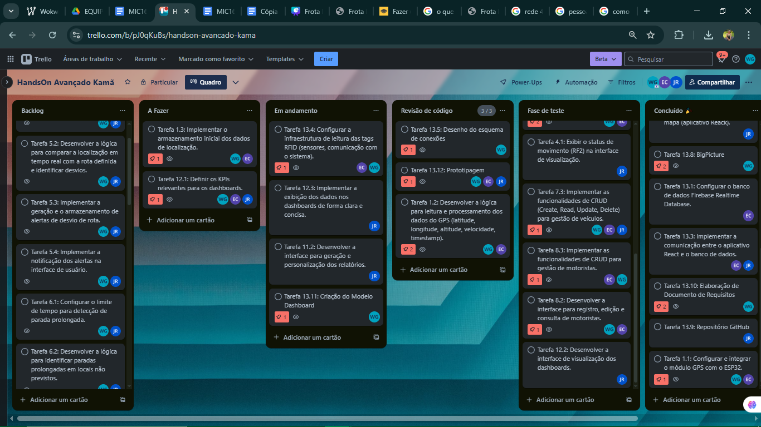

**18/04/2025**

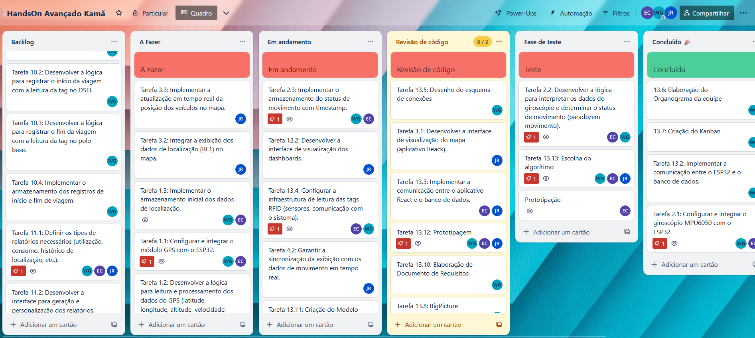

**12/04/2025**

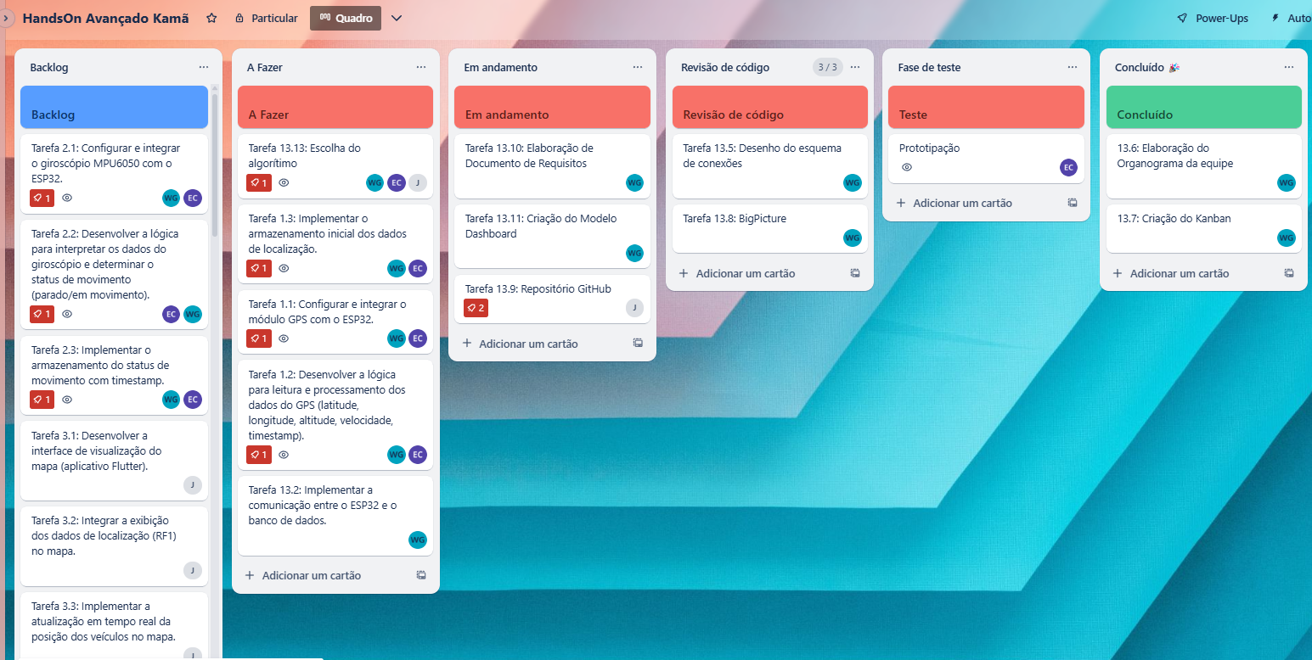

**11/04/2025**

